4.11: a) During the first 2.00 s, the acceleration of the puck is 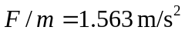 (keeping an extra figure). At 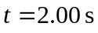, the speed is 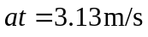 and the position is 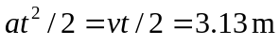. b) The acceleration during this period is also 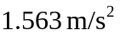, and the speed at 7.00 s is . The position at 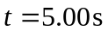 is , and at 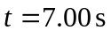 is
or 21.9 m to three places.

